Digital Forensics  Diploma in CSF/IT  Year 2/3 (2025/26) Semester 4/6 | Week 7
 | Tutorial 6
NTFS Analysis

OBJECTIVES

After completing this topic, you should be able to
- Perform Hexadecimal number addition without using calculator;
- Perform forensic analysis on NTFS file system;
- Explain the difference between different timestamps in MFT.

Q1: Perform addition on the hexadecimal numbers using Table 1.
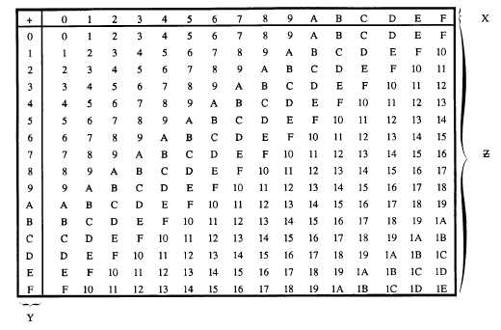
Figure 1: Hexadecimal Addition Table

 | 4 | 5 | 6₁₆
+ | 7 | 8 | 4₁₆
 | B | D | A

 | 7+1 | 8 | 4₁₆
+ | B | D | A₁₆
1 | 3 | 5 | e

 | 9 +1 =A | 8₁₆
+ | 7 | 8₁₆
1 | 1 | 0

Q2. Figure 2-1 shows the MFT record of an NTFS file system.

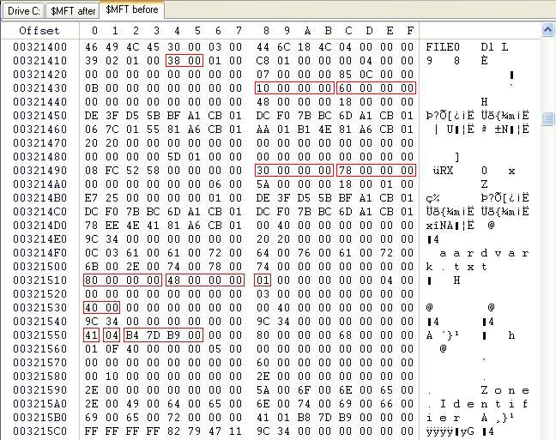

Figure 2-1: MFT File Record

10 00 00 00 = id for the name attribute
60 00 00 00 = the length for the 10 00 00 00
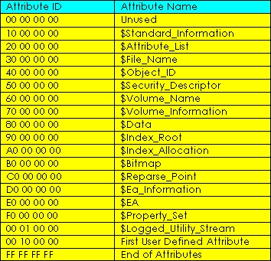
Figure 2-2: NTFS Attributes

Answer the following with reference to Figure 2-1 and 2-2. You may use Hex addition table or calculator to perform the addition.

- What is the byte offset to the first attribute? 0x38

- What is the attribute name of this first attribute? Standard information

The next 4 bytes immediately after attribute type is the length (in bytes) of that attribute.

- What is the length of first attribute? 0x60

- What is the byte offset of second attribute? 0x60 + 0x38 = 0x98 or since its 60 = 6 rows, so count 6 rows = 98

- What is the attribute name of second attribute? File name

- What is the name of the file in this entry? Aardvar.txt

- What is the byte offset of the file content ($Data)? 0x78 + 0x98 = 110 in hex

To find the byte offset of the third attribute ($Data) is = 0x78 + 0x98
0x78 = length of the second attribute
Byte offset means the content from 1 location to the end of the second location.
Calculate the byte offset = need to calcaulte from the end of the length and the previous byte offset.

Q3. (a) An investigator was examining a hard disk drive that was formatted with NTFS file system. Figure 3(a)-1 shows an entry/record in the Master File Table (MFT) and Figure 3(a)-2 and Figure 3(a)-3 show the list of NTFS attributes and Attribute header respectively.
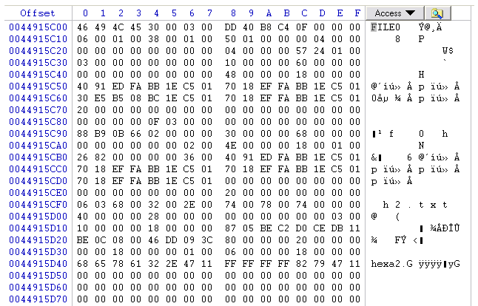
Byte offset 0x38
Figure 3(a)-1: An Entry/Record in Master File Table

Figure 3(a)-2: NTFS Attributes

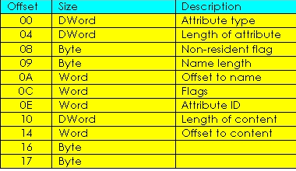
Figure 3(a)-3: Attribute Header

Given that the byte offset to the first attribute is 0x38 (hex), based on Figure 3(a)-1 to 3(a)-3 above, answer the following questions:

  - How do you tell if this MFT entry is a valid/usable entry? What represents an unusable entry?
If the mft entry has the identifier FILE its valid
If its BAAD, then it’s a unusable entry

  - What is the name of the file/folder represented by this entry?
H2.txt

  - Complete the following table for this MFT entry.

 | Attribute Name
1st Attribute | Standard information
2nd Attribute | File name
3rd Attribute | Object ID
4th Attribute | Data

  - Is the 4th attribute a Resident or Non-resident attribute? Explain.
It’s a resident. Because at 80 00 00 00 is the 4th attribute, then at the length of this attribute is 20 00 00 00. Since the behind is 00 and the starting of the new row is a 00, it’s a resident. If the starting of the new row is 01, it’s a non-resident.

  - Which location on the hard disk can you find the content of this file? Explain.
MFT Table

(b) Briefly explain how Windows operating system stores files of the following sizes in disk drive configured with NTFS with respect to the Master File Table (MFT). In your answers, explain how the Non-Resident flag is set.
  - 100 Bytes
  - 5 Kbytes
100 bytes can fit into the mft table so it’s a resident
5 kbytes cannot fit into the table because its more than 1024, so its not a resident

Q4. Where is the Volume Boot Record (VBR) located in the NTFS partition?
The Volume Boot Record (VBR) is located at the first logical sector of the partition (the partition's LBA start). In your Laura case the partition’s first logical sector is LBA 2048 (so the VBR is at PS 2048). The VBR contains the NTFS OEM ID, bytes/sector, sectors/cluster, and the total sectors field.

Q5. Both $Standard_Information and $File_Name contain MACE timestamps. Explain the difference between the timestamps found in these 2 attributes.
• $STANDARD_INFORMATION timestamps: these are the canonical file timestamps maintained by the file system for the file object itself (these reflect changes to the file’s metadata and content). They represent the OS’s record of when the file was created, last modified (M), last accessed (A), and when metadata was last changed (C).
• $FILE_NAME timestamps: these are filename-entry timestamps and are recorded in the directory entry for that filename. They may reflect the state of the file at the time the filename record was created or last changed and can change when the file is renamed or moved (because moving to a different directory creates a new filename entry). For this reason the two timestamp sets may disagree (e.g., a file renamed will have a new MACE in $FILE_NAME but $STANDARD_INFORMATION’s created/modified times remain the same).

- End -

